Follow these steps to be able to retrieve your desired MassID.

Step 1: Go to https://mycatholic.sg/home
Step 2: Navigate to where all the masses for the month is.
Step 3: Press F12 on your keyboard
Step 4: Right Click your desired mass you wish to observe and book
Step5: Click on Inspect
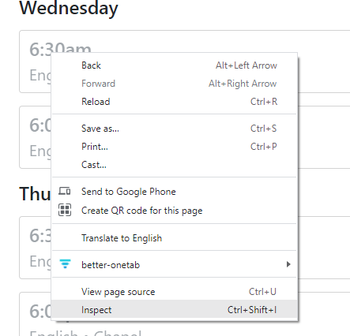

You should see a small box come up at the bottom of Chrome.
Step 6: Go to any of the mass you wish and repeat step 4-5. Retrieve these text.
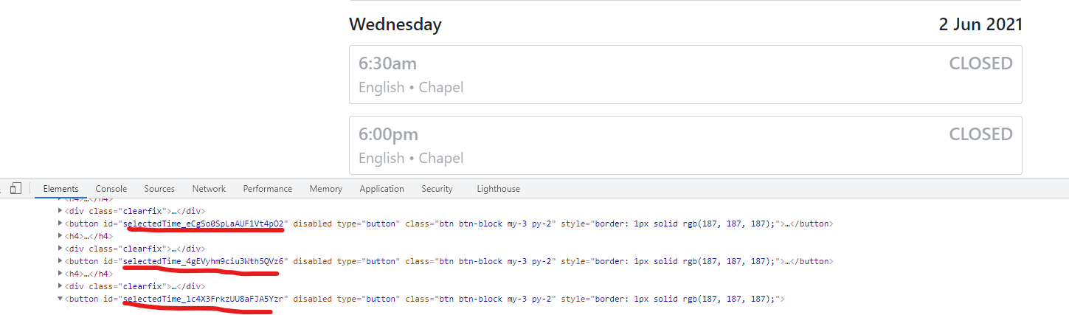

Eg. selectedTime_G9iz3ePeje0ZWEDatpXX
Step 7: You can take note of these IDs. Next paste it in a line separated by spaces for each ID over in the ScriptInput.txt

